Air Quality Prediction System using Machine Learning

Project Id: 15

Name : Priyanshi (Team Leader)
Class Roll Number:13
University Roll Number : 2028468
Section and Group: Q(G1)

Name : Taniya
Class Roll Number:18
University Roll Number : 2028510
Section and Group: Q(G1)

Name : Ananya Singhal
Class Roll Number:29
University Roll Number : 2028639
Section and Group: Q(G1)

TABLE OF CONTENTS
- Problem Description 3
  - Dataset Description 3
  - Flow diagram 4
- Modules for Project Implementation…………………..…………………………5
  - Modules Used 5
  - Platform Used 6
- Machine Learning model/ Searching Technique used 7
- Evaluation metrics used 8
- Results and Visualizations 9
- Conclusion and Future Scope 11
- References 12

- Problem Description
Air pollution is one of the most serious environmental challenges affecting human health and climate conditions. Monitoring and predicting air quality levels can help authorities and citizens take preventive actions to reduce exposure to harmful pollutants.
The main objective of this project is to develop a Machine Learning based Air Quality Prediction System capable of predicting future air quality categories using historical pollutant and weather data. The project focuses on analyzing environmental patterns and improving prediction accuracy through preprocessing, feature engineering, feature selection, and machine learning classification techniques.
In Phase 3, the project implements machine learning models for AQI category prediction and evaluates their performance using different evaluation metrics and visualizations.

1.1 Dataset Description
The dataset used in this project is the Air Quality dataset containing pollutant sensor readings and meteorological information.
Dataset Features
The dataset includes:
- CO(GT)
- NMHC(GT)
- NOx(GT)
- NO2(GT)
- Temperature (T)
- Relative Humidity (RH)
- Absolute Humidity (AH)
- PT08 sensor values
The preprocessing stage includes:
- Removal of missing and invalid values
- Handling “-200” values as missing data
- Time-series ordering using date and time columns
- Creation of AQI target categories
Feature engineering techniques used:
- Time-based feature extraction
- Lag feature generation
- Interaction feature generation
- Cyclical encoding for time variables
The final dataset is prepared for machine learning classification models.

1.2 Flow Diagram

Dataset Collection
↓
Data Cleaning and Preprocessing
↓
Feature Engineering
↓
Feature Selection
↓
Train-Test Split
↓
Machine Learning Model Training
↓
Model Evaluation
↓
AQI Category Prediction

2. Modules for Project Implementation

2.1 Modules Used

The following Python modules and libraries are used in the project:
Module | Purpose
Pandas | Data manipulation and preprocessing
NumPy | Numerical computations
Matplotlib | Data visualization
Scikit-learn | Machine learning algorithms and evaluation
Pickle | Model saving and loading
Pathlib | File handling and directory management

Machine Learning Modules

Logistic Regression

K-Nearest Neighbors (KNN)

Support Vector Machine (SVM)

Feature Engineering Modules

SelectKBest

StandardScaler

SimpleImputer

.

2.2 Platform Used: (mention all the platforms with the reason of using it)

Hardware Requirements

- Processor: Intel i3 or above
- RAM: 4GB minimum
- Storage: 10GB free space

Software Requirements
- Python 3.x
- Jupyter Notebook
- VS Code / PyCharm
- Windows Operating System

Libraries and Tools
- Pandas
- NumPy
- Scikit-learn
- Matplotlib

3. Machine Learning Model/ Searching Technique Used(Describe each ML model/ searching technique used)

The project uses supervised machine learning classification models for predicting AQI categories.

1. Logistic Regression
Logistic Regression is used as a baseline classification model for predicting AQI categories.

2. K-Nearest Neighbors (KNN)
KNN predicts AQI categories based on similarity between neighboring data points.

3. Support Vector Machine (SVM)
SVM is used for classification by finding optimal hyperplanes between AQI classes.

Feature Selection Technique
The project uses ANOVA F-score ranking with SelectKBest for selecting the most relevant features.

Data Processing Techniques
- Median Imputation for missing values
- StandardScaler for normalization
- Lag Feature Engineering
- Time-Based Feature Extraction

4. Evaluation metrics used (Describe each evaluation metric used along with formulae)

The following evaluation metrics are used to measure model performance:
Accuracy
Measures overall prediction correctness.
$$Accuracy=\frac{TP+TN}{TP+TN+FP+FN}$$
Precision
Measures the correctness of positive predictions.
$$Precision=\frac{TP}{TP+FP}$$
Recall
Measures the ability to correctly identify positive cases.
$$Recall=\frac{TP}{TP+FN}$$
F1-Score
Provides the harmonic mean of precision and recall.
$$F1=2×\frac{Precision×Recall}{Precision+Recall}$$
ROC-AUC Score
Measures classification performance using ROC curves.
Additional evaluation methods:
- Confusion Matrix
- Classification Report
- Per-class AUC analysis

5. Results and Visualizations

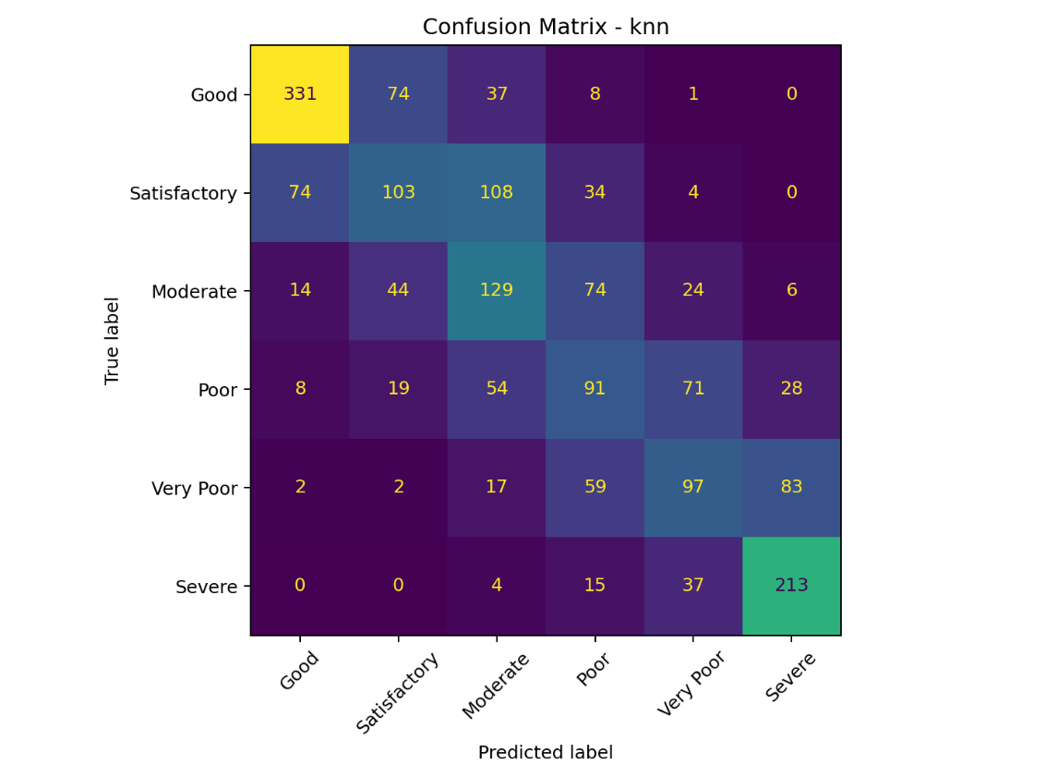

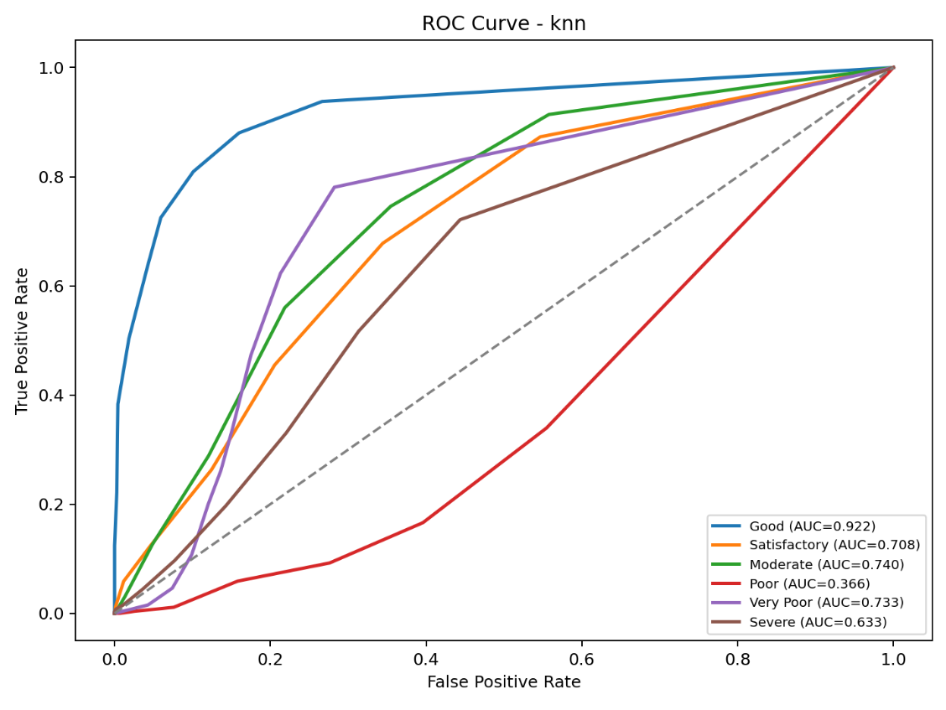
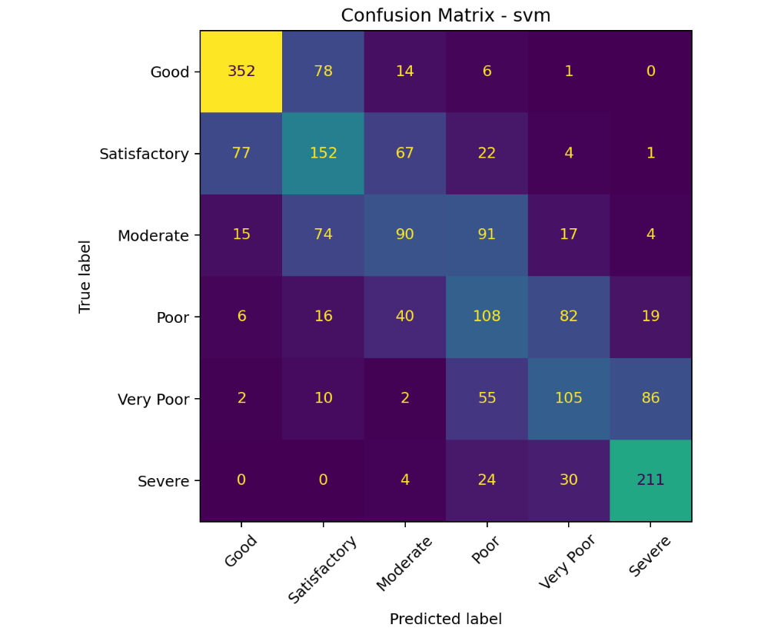

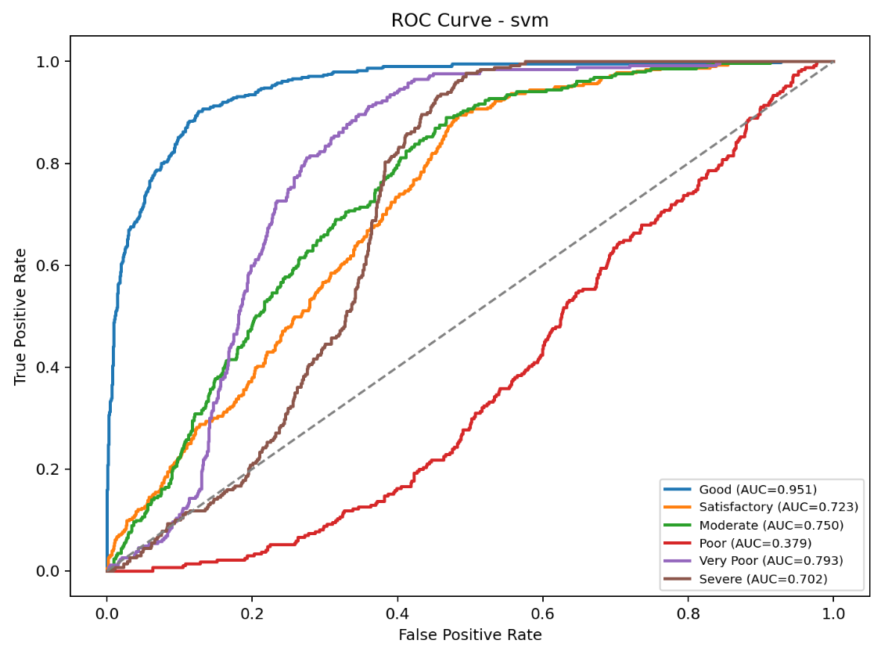

6. Conclusion and Future Scope:

Conclusion
The Air Quality Prediction project successfully implemented machine learning classification models for predicting AQI categories. The project performed preprocessing, feature engineering, feature selection, and model evaluation effectively.

The developed system demonstrates that machine learning techniques can accurately analyze environmental and pollutant data to predict air quality conditions.
The project also highlights the importance of:
- Time-series analysis
- Lag feature engineering
- Meteorological feature integration
- Proper preprocessing techniques

Future Scope
Future improvements can include:
- Real-time AQI prediction system
- Deep learning models such as LSTM
- IoT sensor integration
- Web-based AQI dashboard
- Mobile application for live air quality monitoring
- Integration with weather forecasting APIs

- References:
- Air Quality UCI Dataset
- Scikit-learn Official Documentation
- Python Documentation
- Pandas Documentation
- NumPy Documentation
- Matplotlib Documentation
- Research Papers on Air Quality Prediction using Machine Learning
- Environmental Monitoring and AQI Standards

